Assignment for **Oracle E- Business Suite General Ledger**

Date:15th Nov-2024

[Provide screenshots of each step (which performed in a live environment).   
As evidence all the activity screens shot needs to be attached]

1.Create Your Own user ID from System Administrator Responsibility.   
 Assign the following responsibilities to your Oracle User ID

* **Vision Operation General Ledger.**
* **Vision Operation Inventory**.
* **Vision Operation Procurement**

2. For your user ID password expiration day should be 60 days

3. In **Vision Operation General Ledger** responsibility.

Form Accounting Setup Manager> Find the **Vision Operation [Primary Ledger]**

In this Ledger finds the **4C** Component, mentions the 4C name & take the screen shot as Evidence.

1. Find the Respective Calendar **Vision Operation [Primary Ledger].**

4.Find all the **Account Code Combinations.**

5.Find all the Journals [**SOURCE: Payables].**

6. In Journal Header from record History find the respective **Data base Table name.**

7. Find the one Manual [Source] & one Payable [Source].

8.How can you review posted journal entries in Oracle GL? Steps & screen shots

9. Find the **Chart of Accounts [COA]** Structure in General Ledger.

10.How are you going to run one **Concurrent Request** from General Ledger (Navigation).

11. In One Ledger Set what are all components common in all the Ledger?

12. Find how many types of accounts in Oracle GL [Account Code Combination]?

13. Check & show the Structure of Chart of Account segment structure.

1. Navigation: **System Administrator>Security>User>Define**

There was no responsibility named procurement, so I used purchasing, which is what we have been using in class.

User ID: XX_CJW_USER - Password: welcome123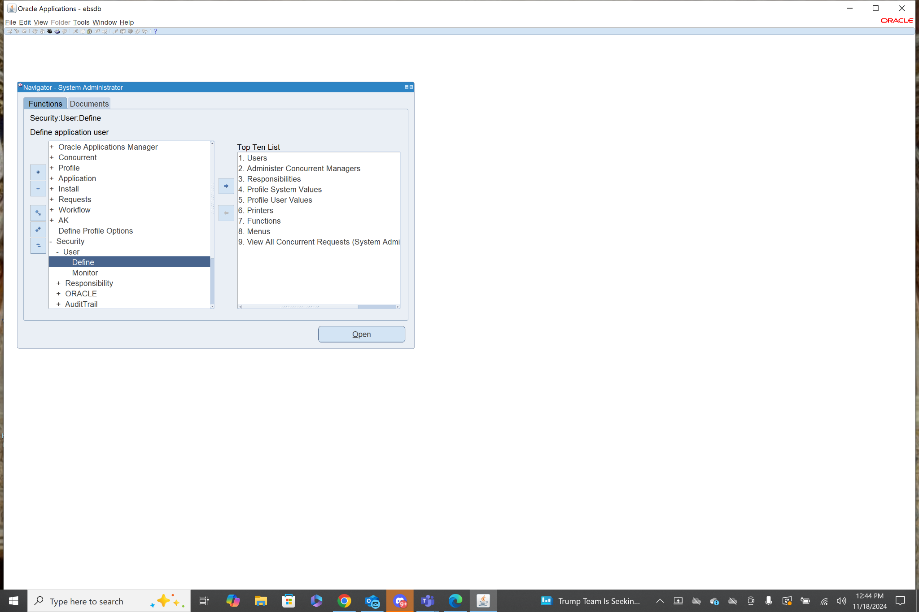1 & 2. 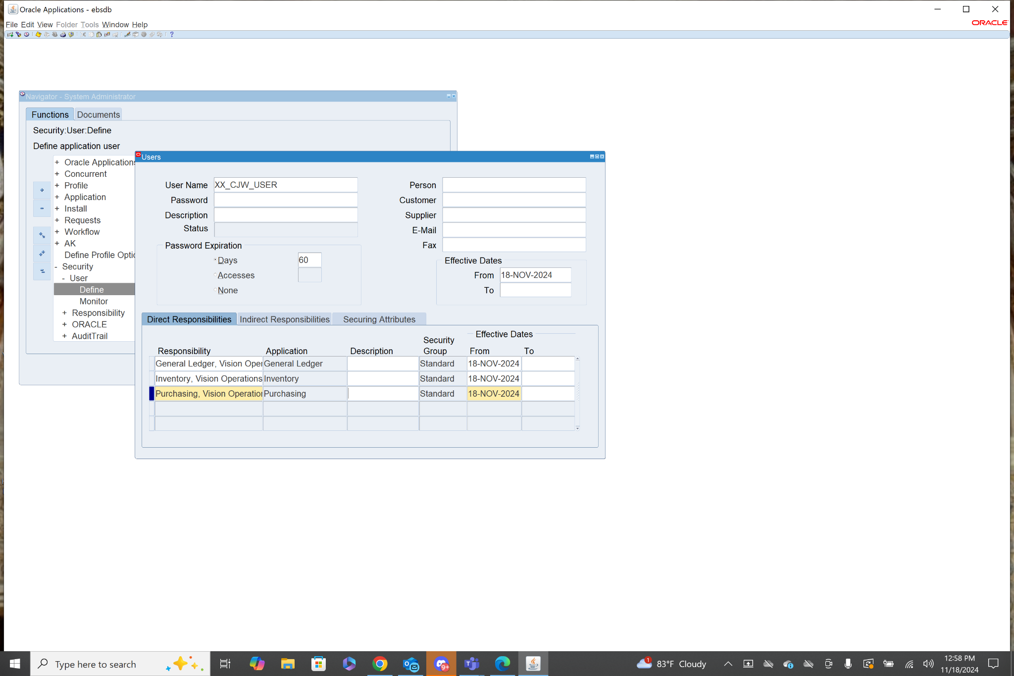

3. Navigation: **General Ledger>Setup>Financials>Accounting Setup Manager> Accounting Setups**

This takes you to the webpage where you can search for ledgers. I searched for Vision Operations, then clicked update accounting options, then under Primary Ledger I clicked update on *Vision Operations (USA). This took me to a page detailing the 4C Components.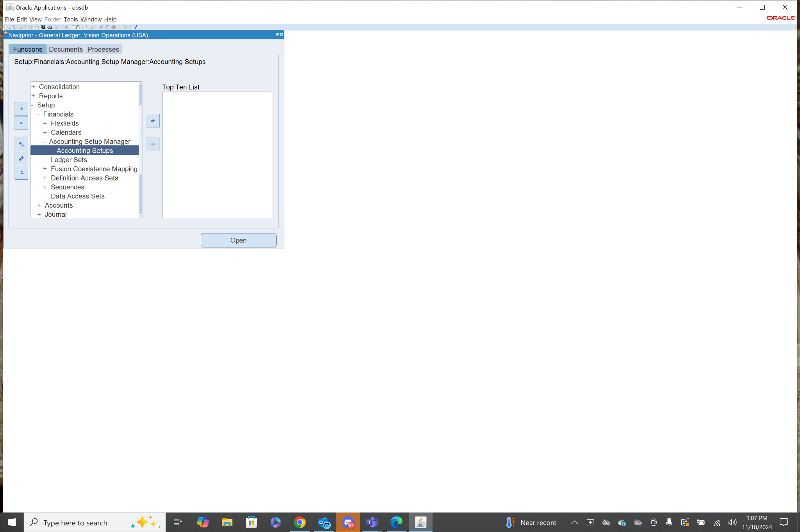

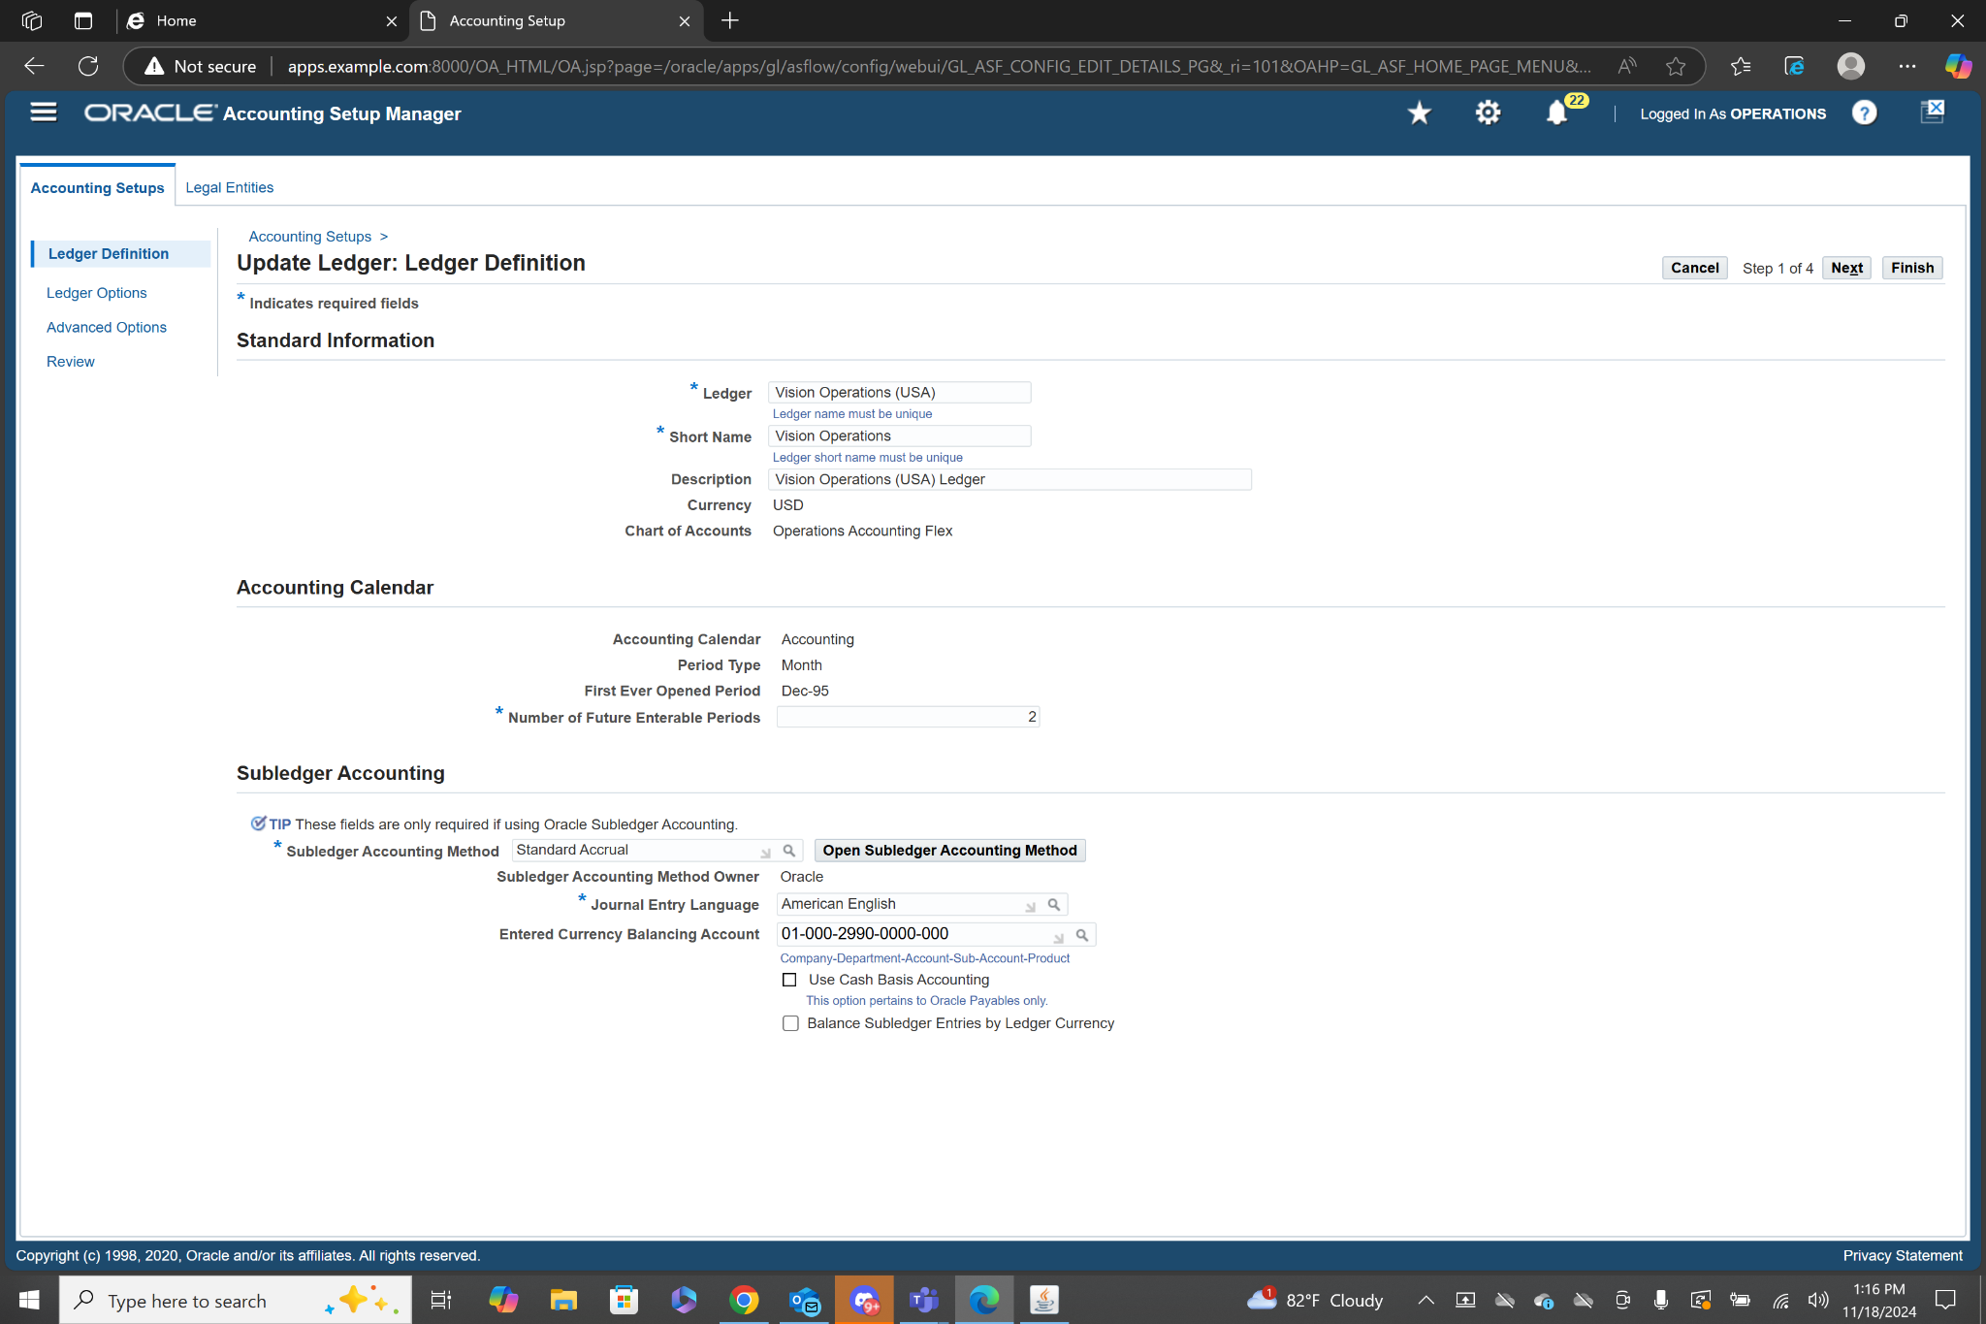

3a. Navigation: **General Ledger>Setup> Financials>Calendars>Accounting**

When looking at the details of the Vision Operations Primary ledger it shows that the name of the Calendar used is Accounting. After following the navigation above I used ctrl+F11 to search existing calendars. I typed in Accounting% and it showed me the details of that calendar.

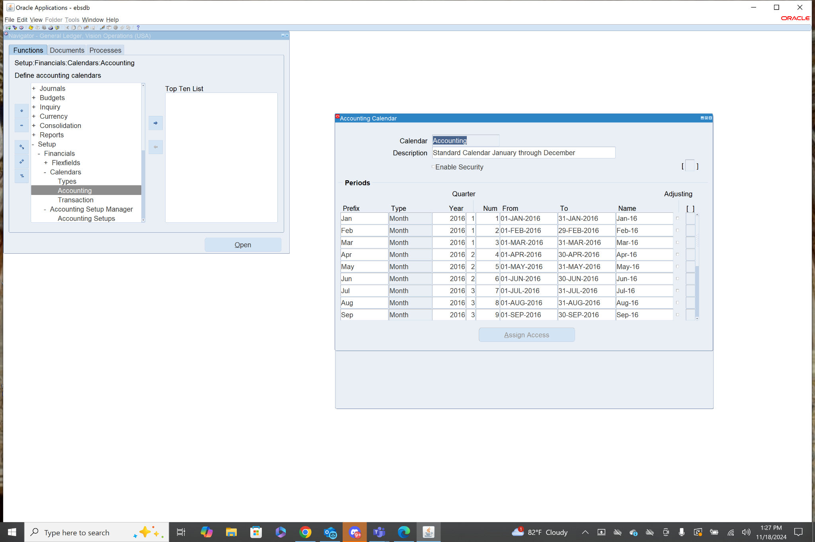

4. Navigation: **General Ledger>Setup>Accounts>Combinations**

After Entering this form I pressed ctrl+fn+f11 and all of the code combinations showed up.

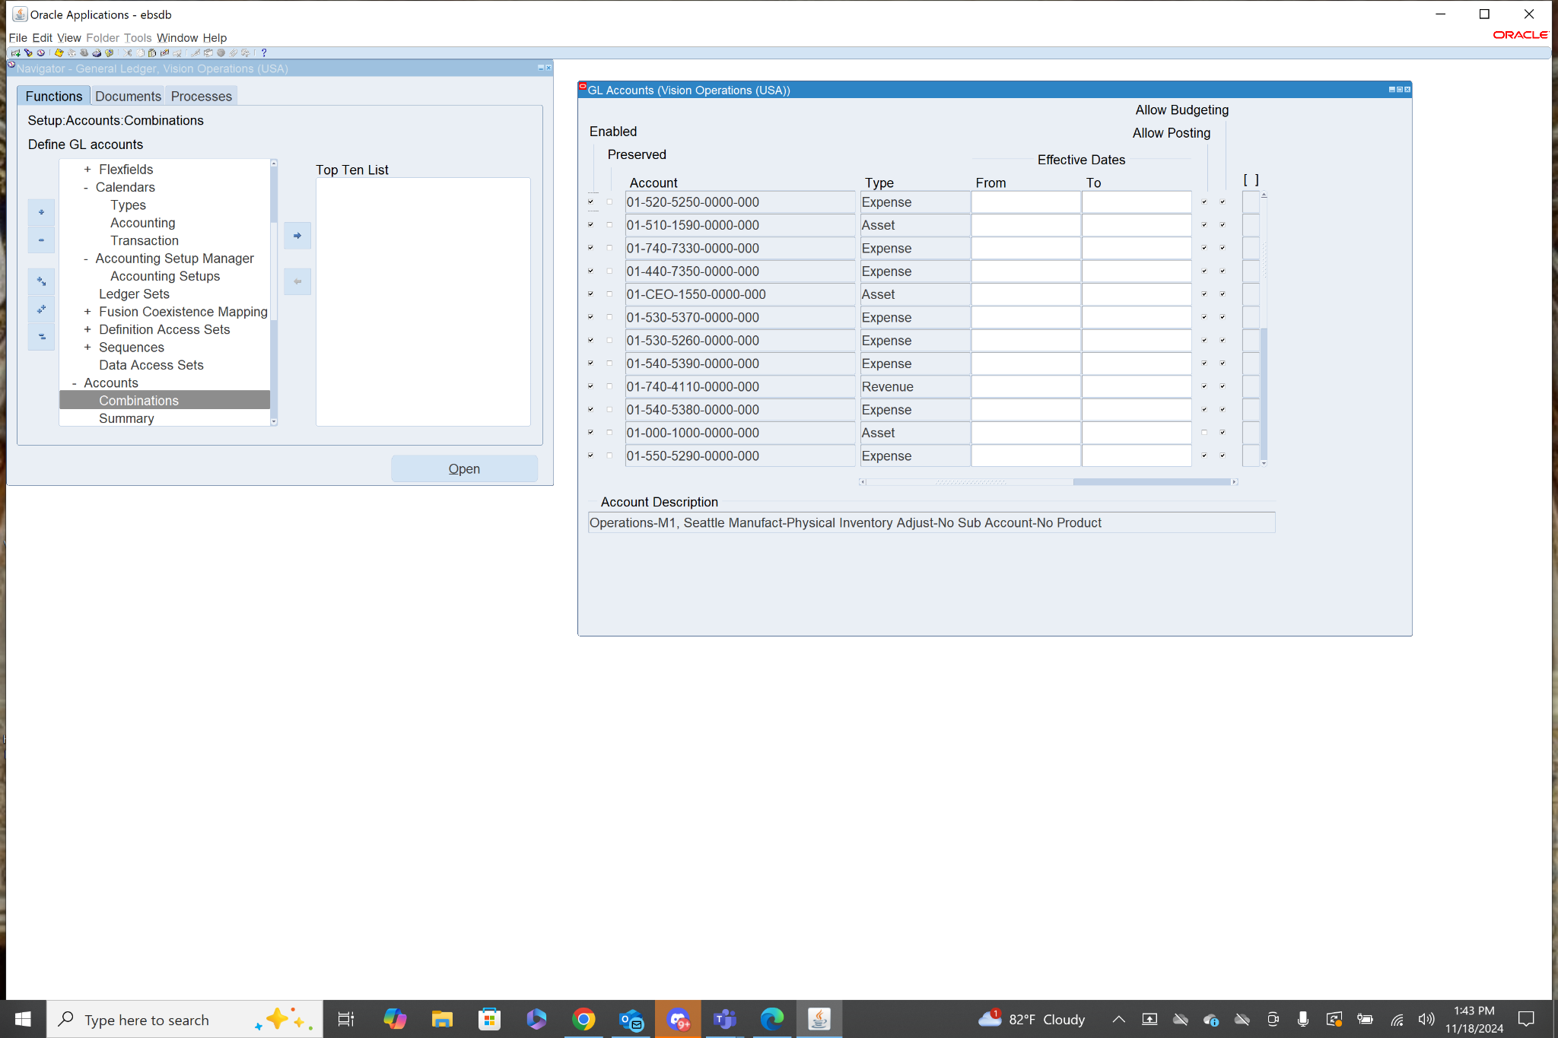

5. Navigation: **General Ledger>Journals>Enter**

After entering this form I went to Source and selected payables, then I clicked find to show the journals with the source payables.

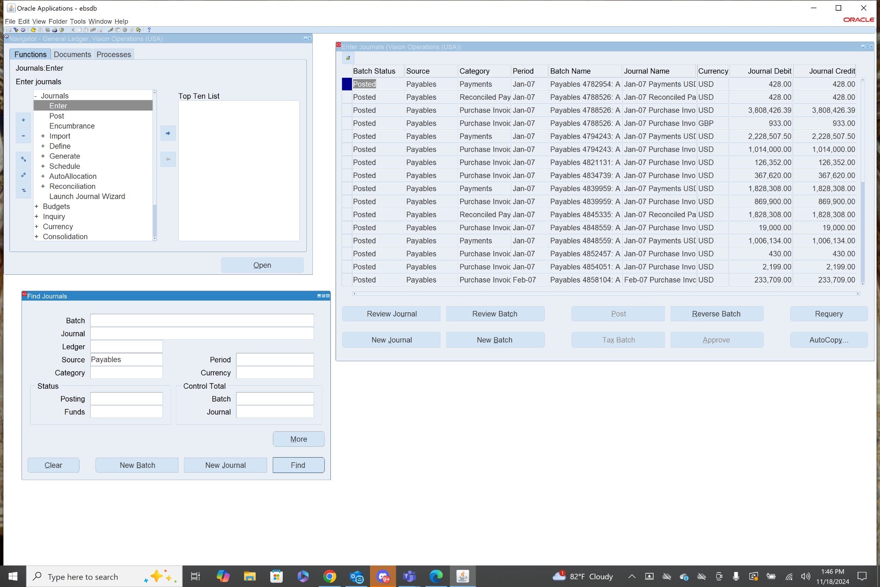

6. Navigation: **General Ledger>Journals>Enter**

To find the database table, while the journals form is open click help at the top and choose record history from the drop down menu. This will show the name of the table in the database.

Table Name: GL_JE_BATCHES_HEADERS_V

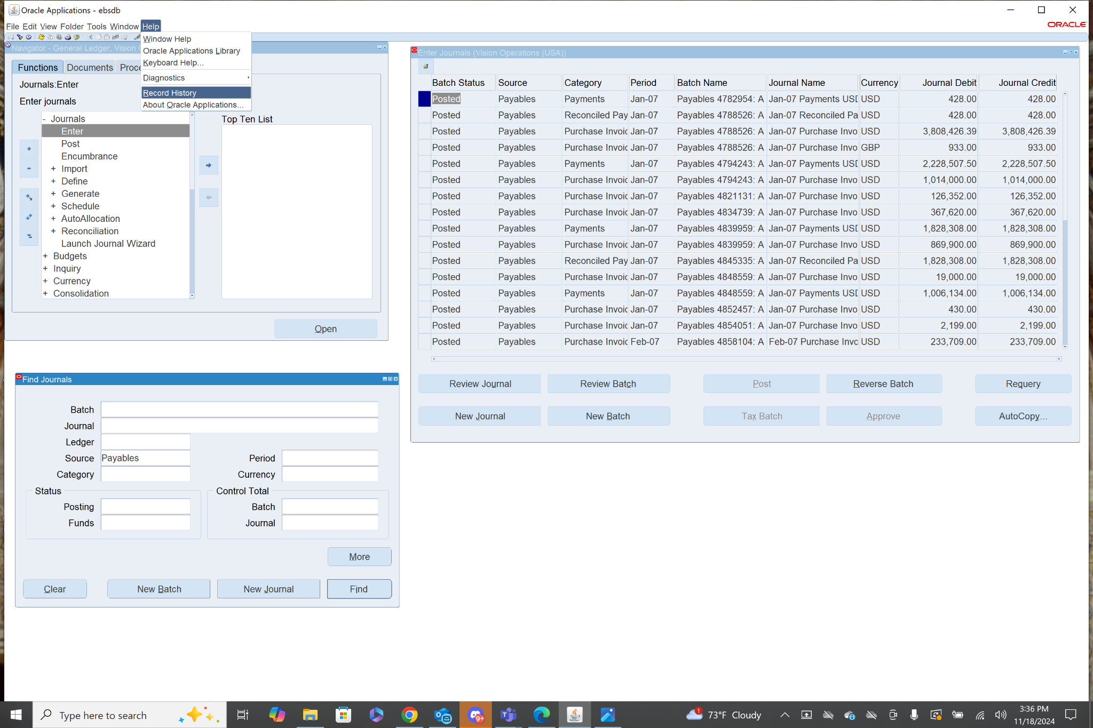

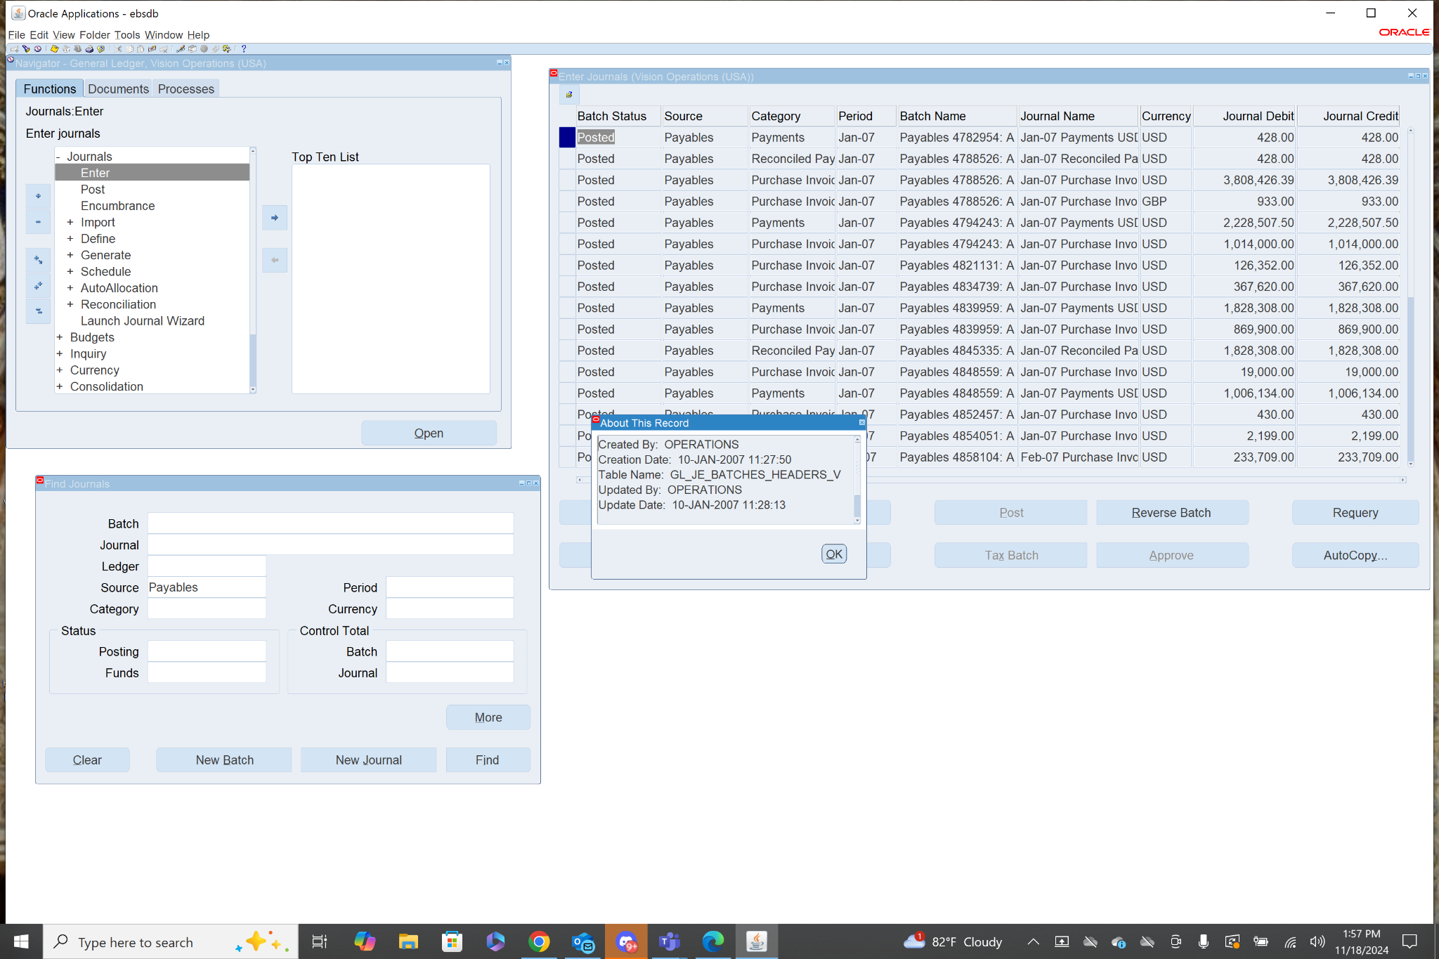

7. Navigation: **General Ledger>Journals>Enter**

From here you are taken to the find journals menu, in the source category there is a drop down where I selected payables and clicked find. Then I selected a journal and clicked review journal. I repeated this process for manual in place of payables.

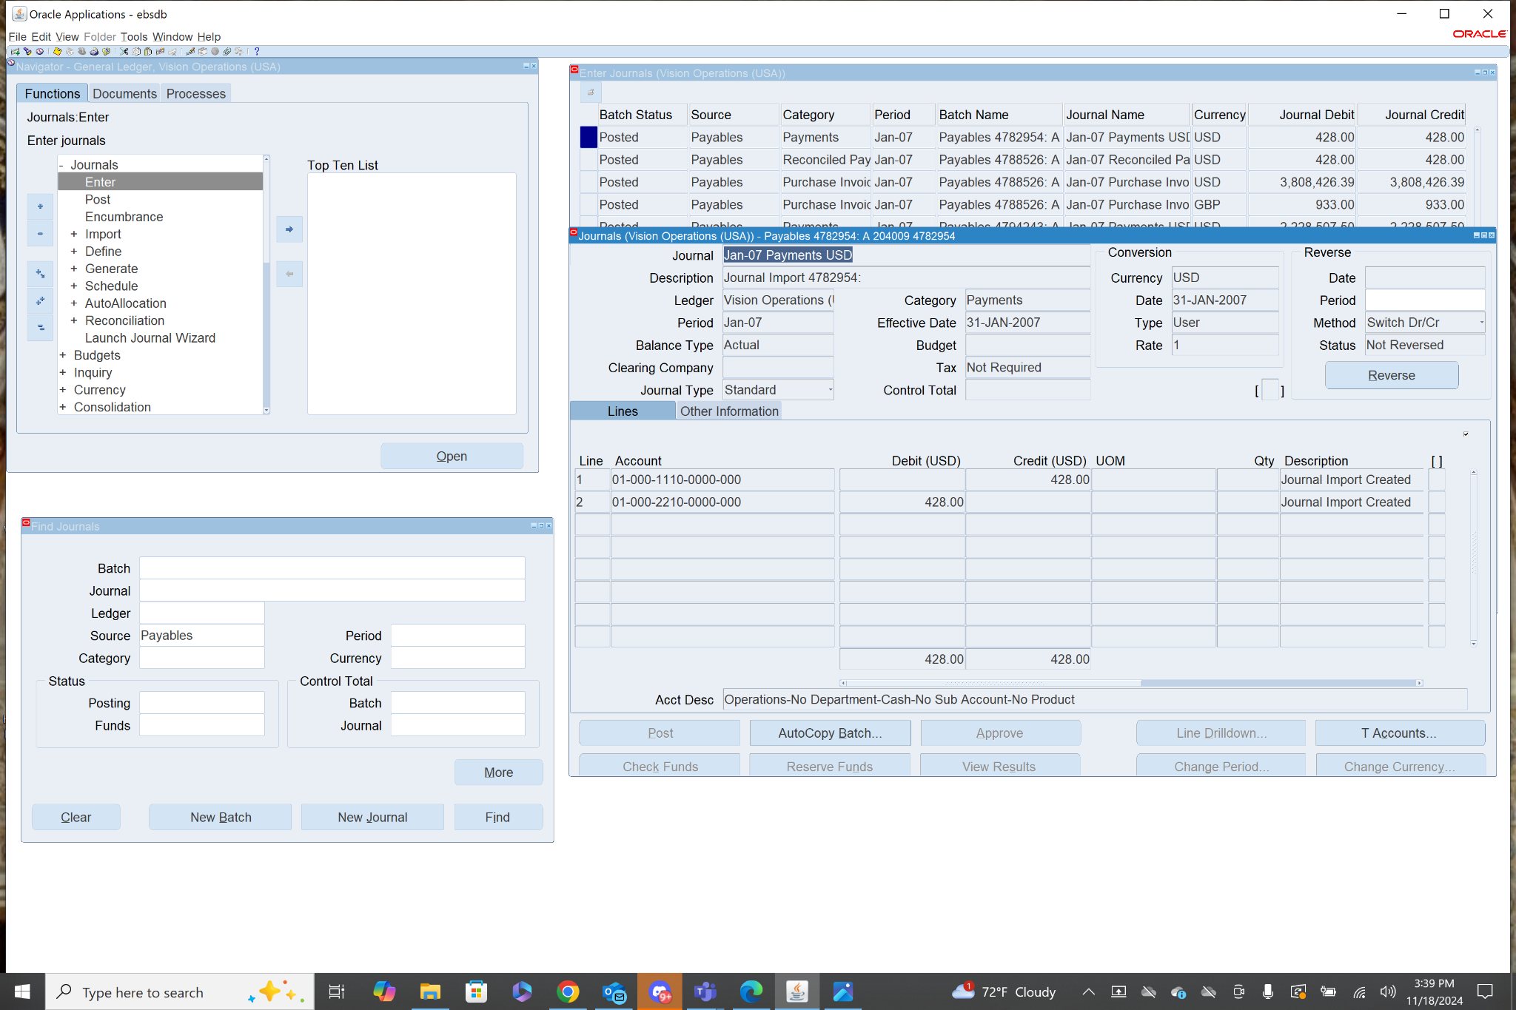

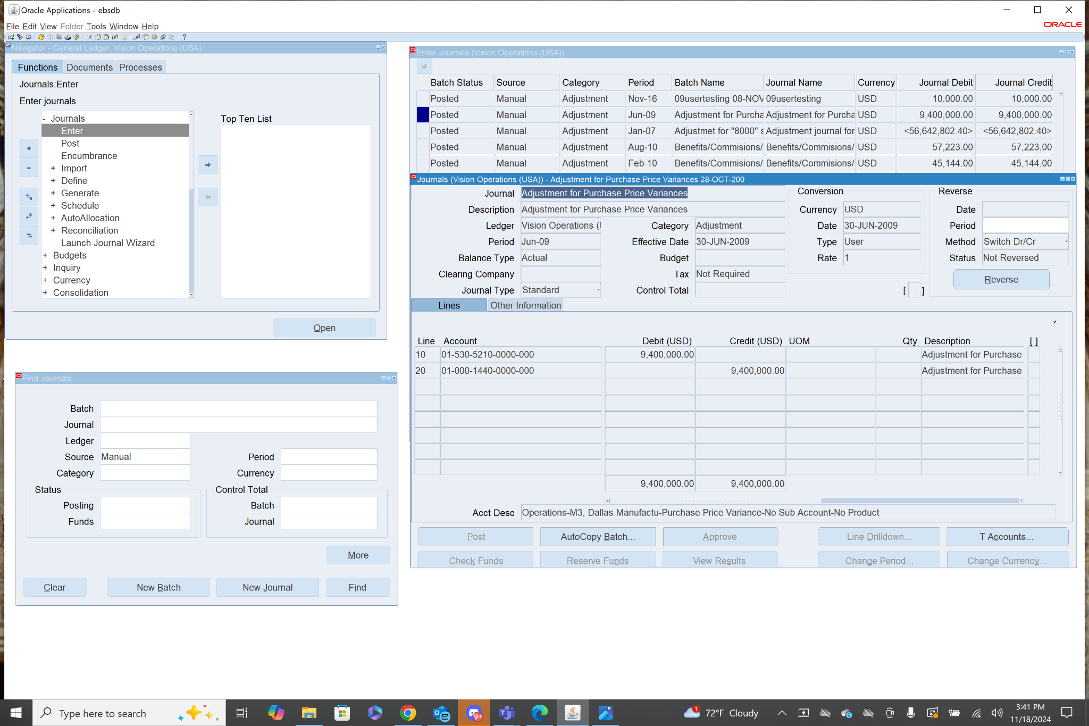

8. First step is to be in the General Ledger Responsibility.

Next, is to select the Journals section and then select the Enter form.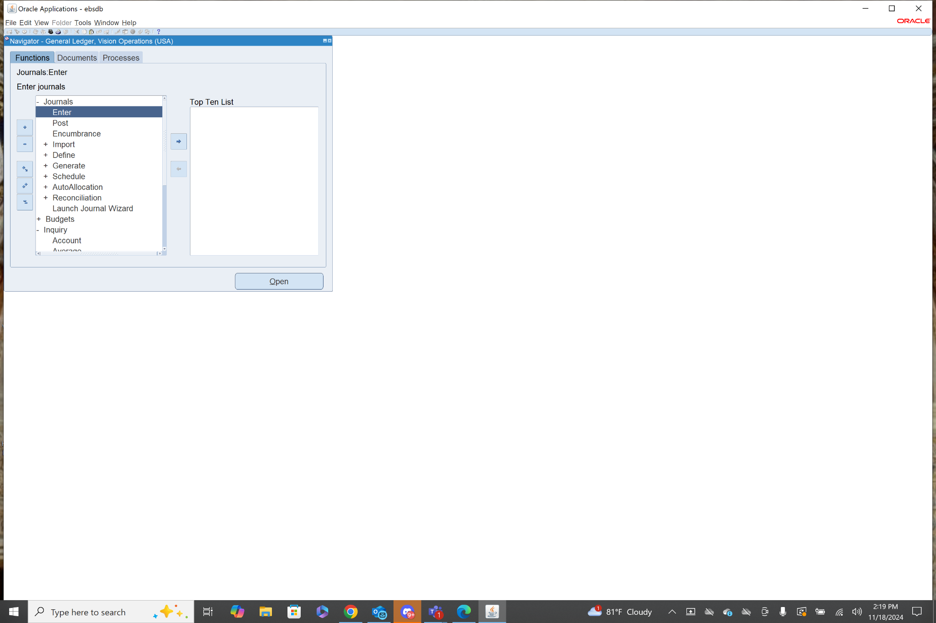

From here we can define criteria that we can use to search for journals in the database.

I will search for journals with the source manual.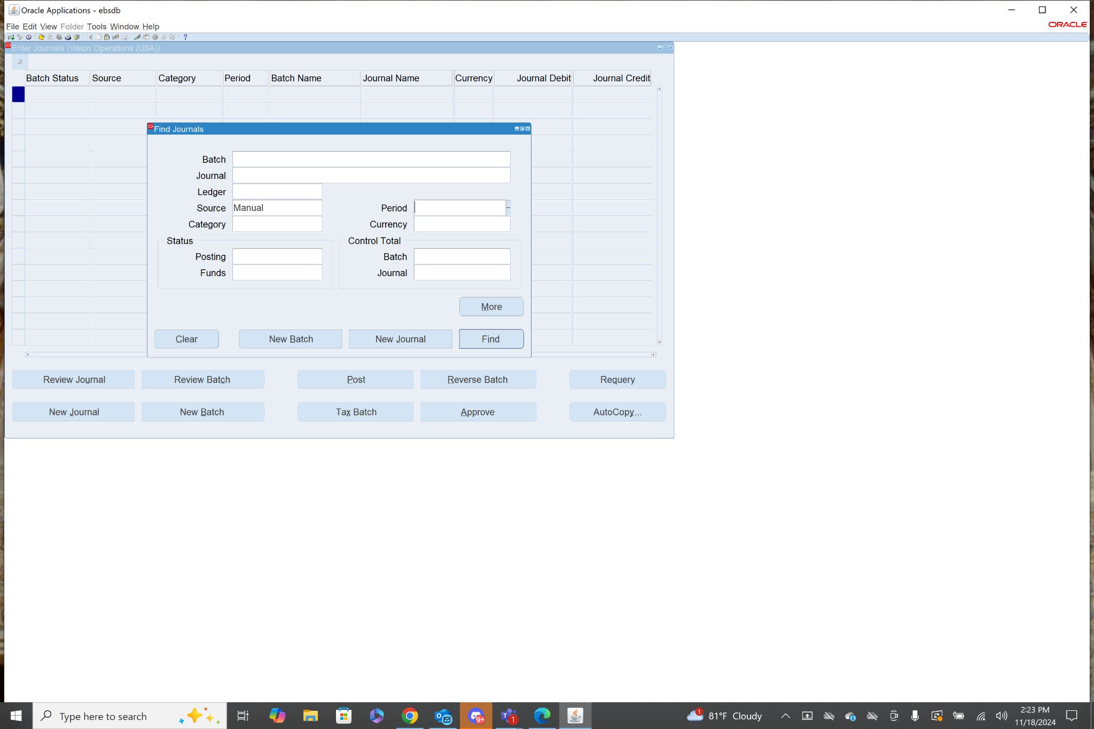

After the list of journals appears we can select a specific journal and click review journal to see it’s details.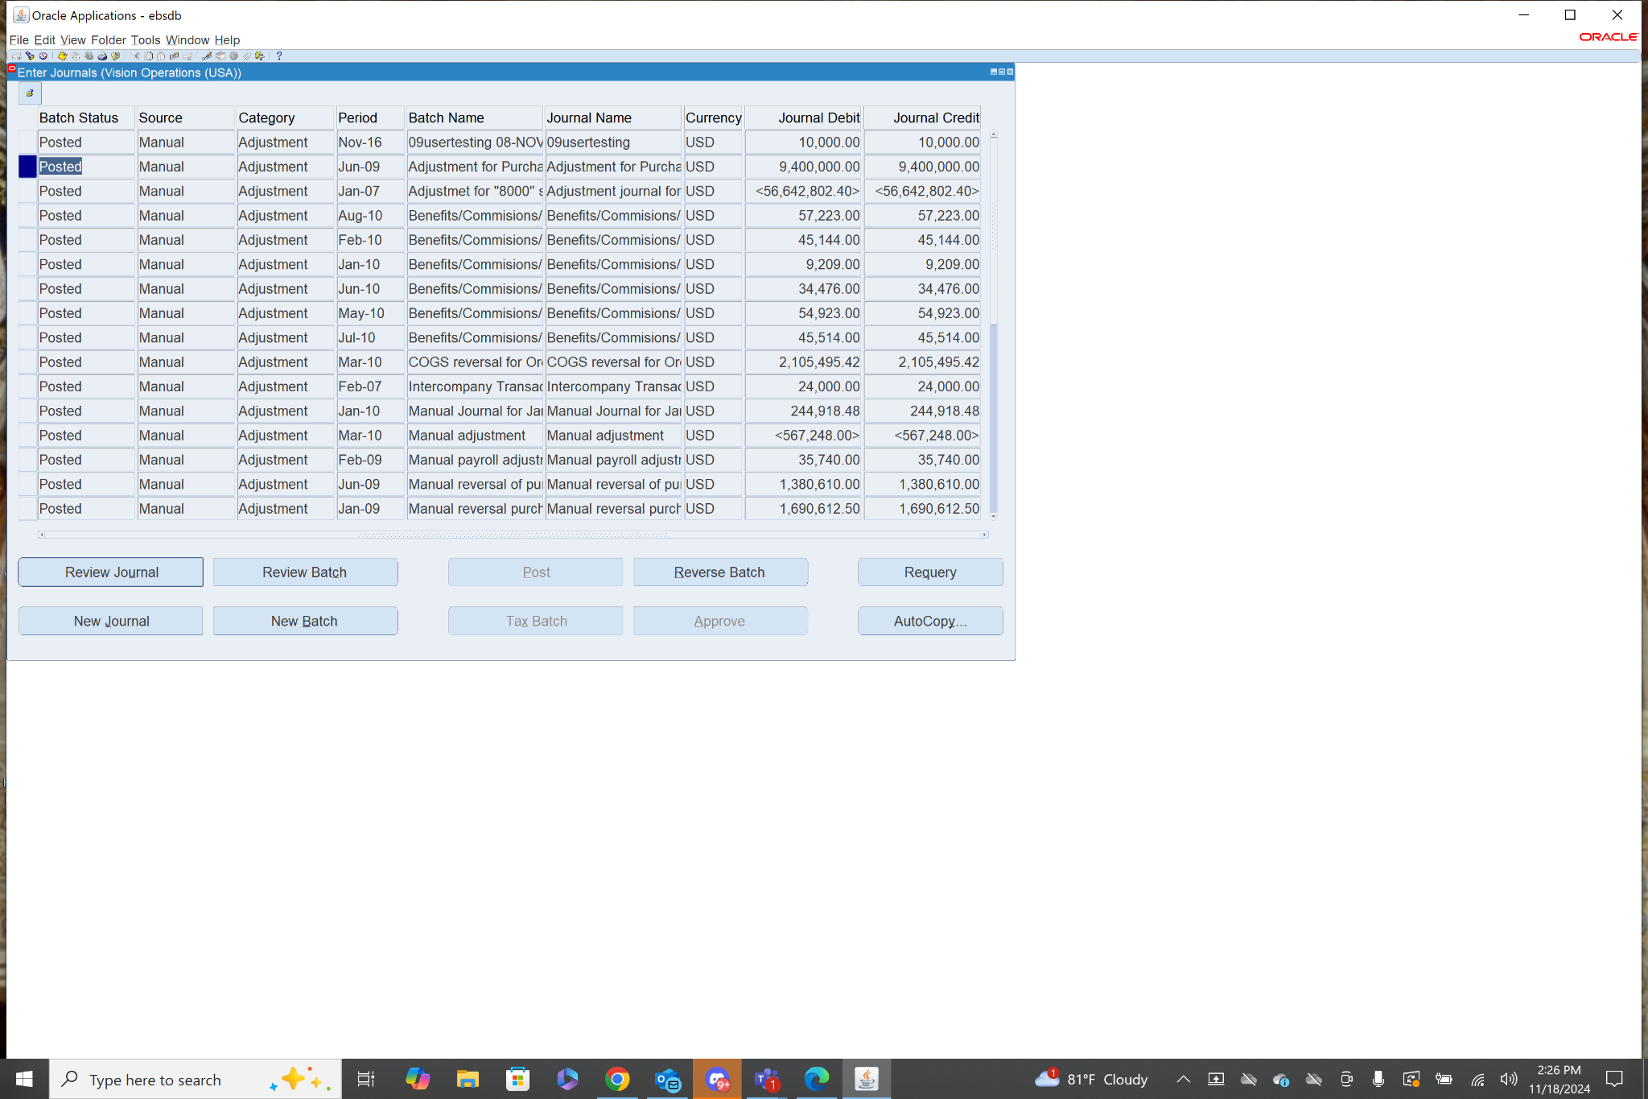

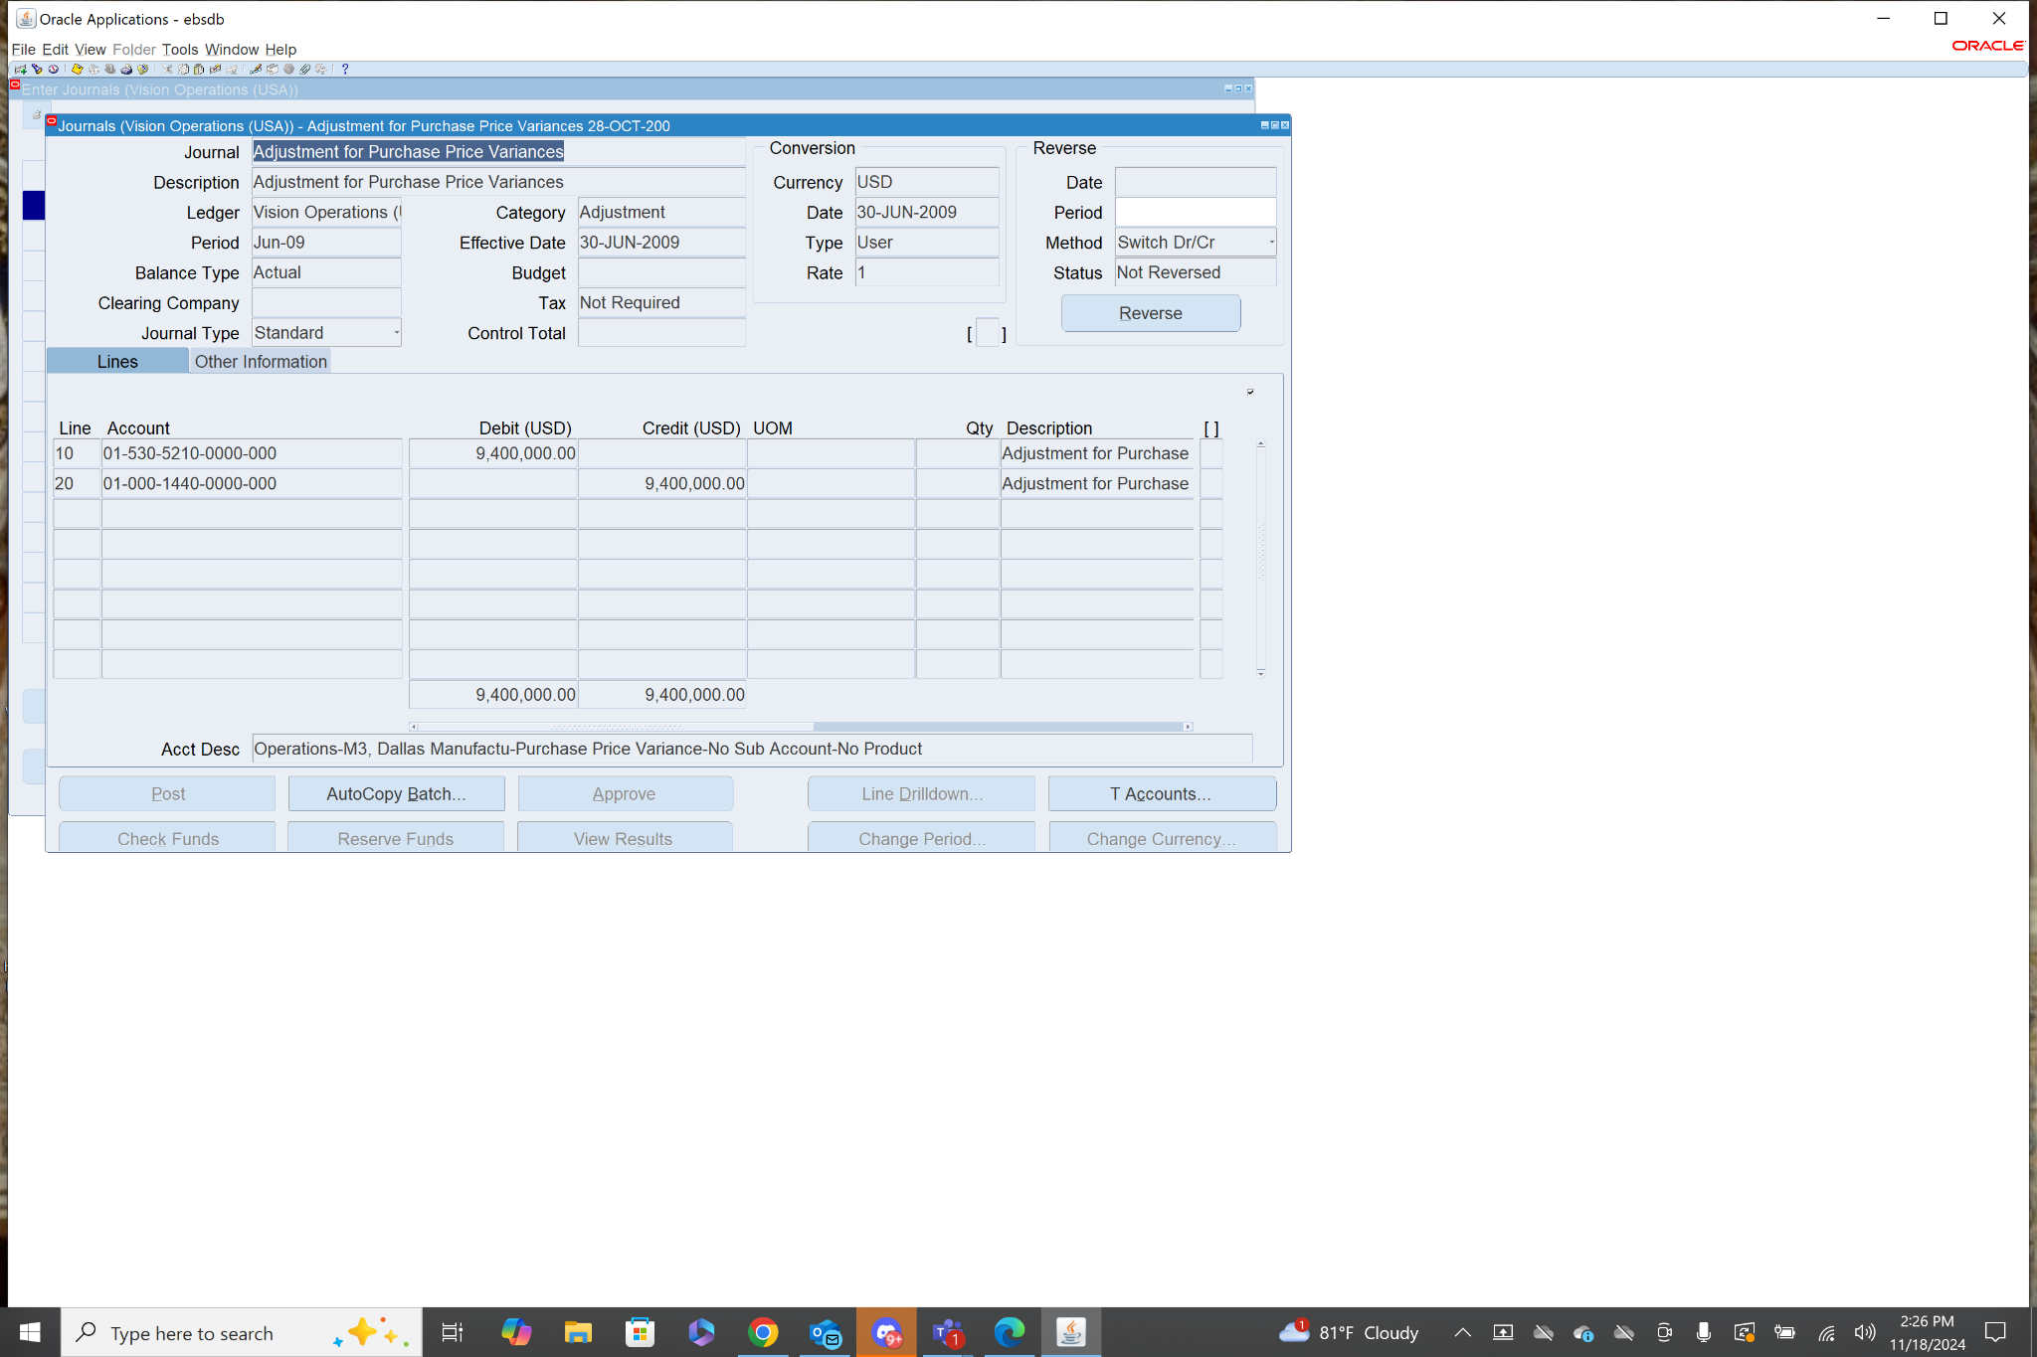

**9 & 13.** Navigation: **General Ledger>Setup>Financials>Flexfields>Segments**

When you enter this form if you press ctrl+f11 and search for General Ledger in the application field. This will show all of the key flexfields under General Ledger including all created chart of accounts.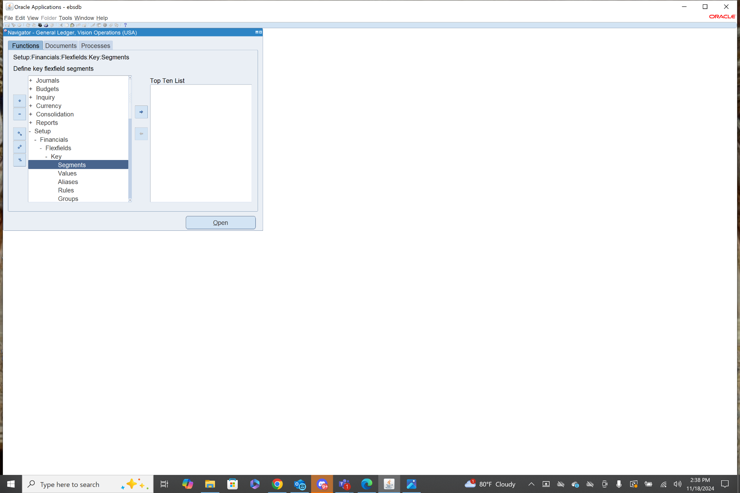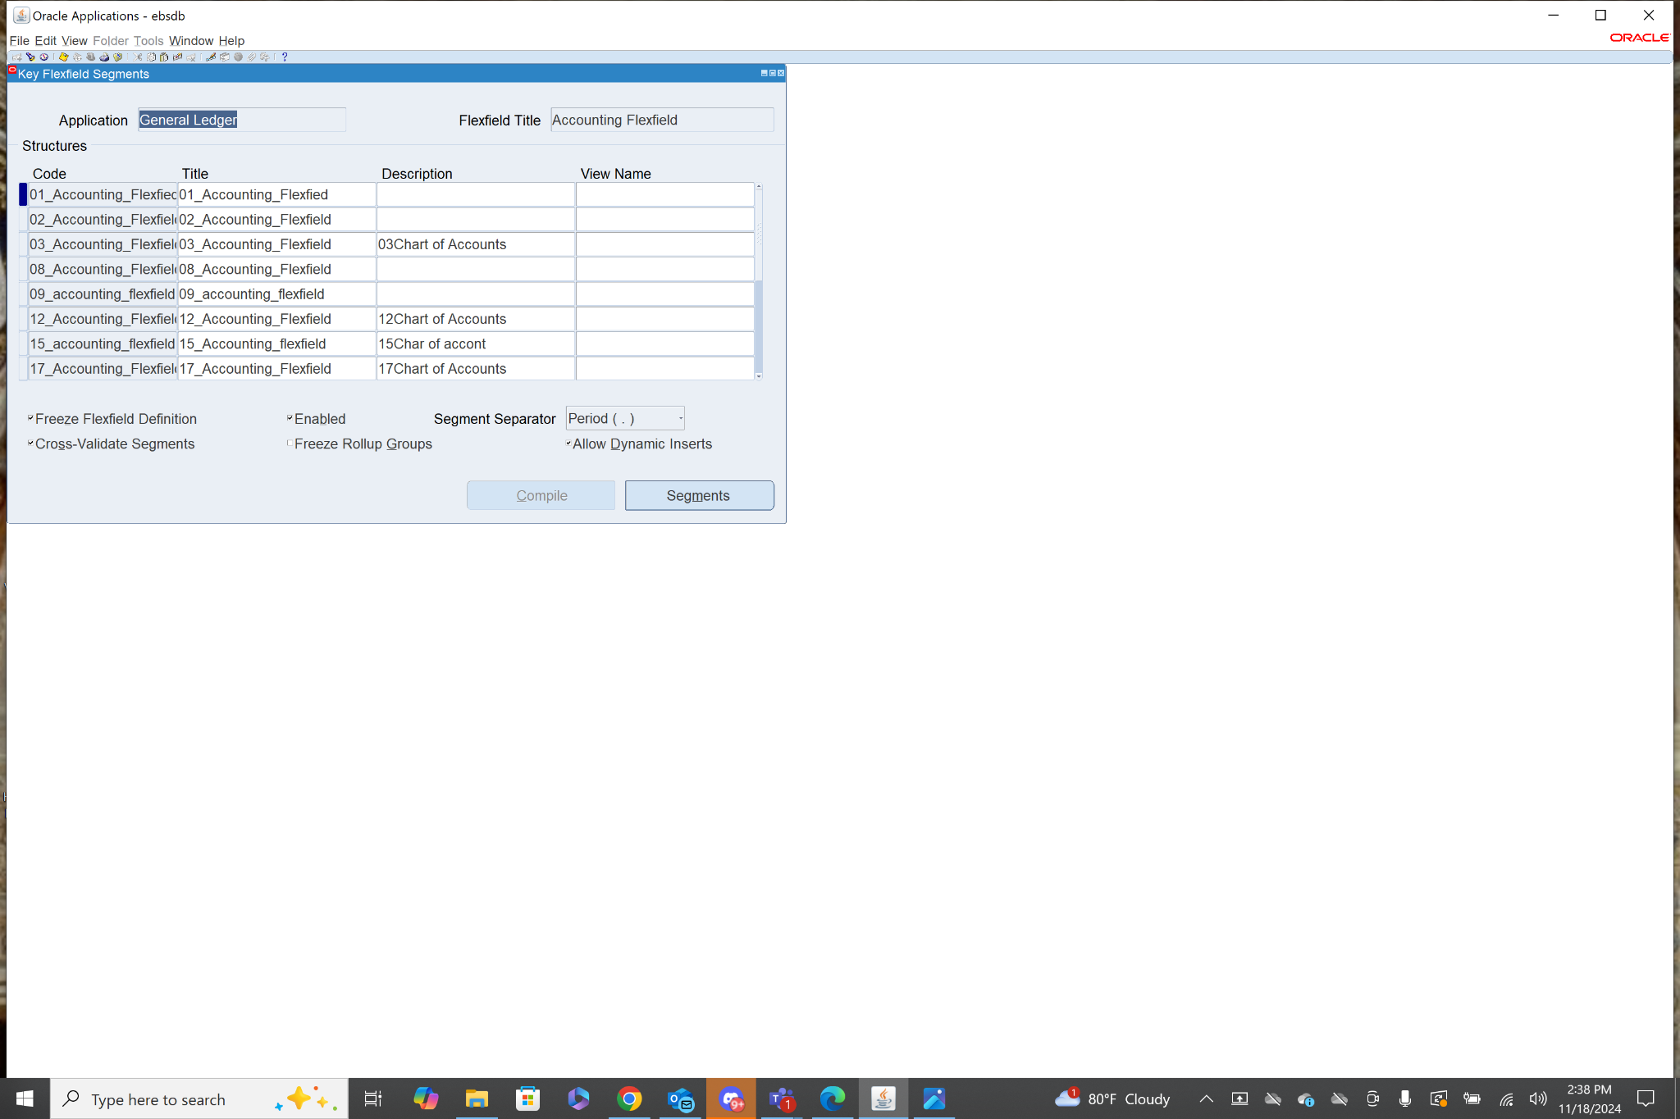Then you can select a chart of accounts and then click segments. This will show the Chart of Account segment structure.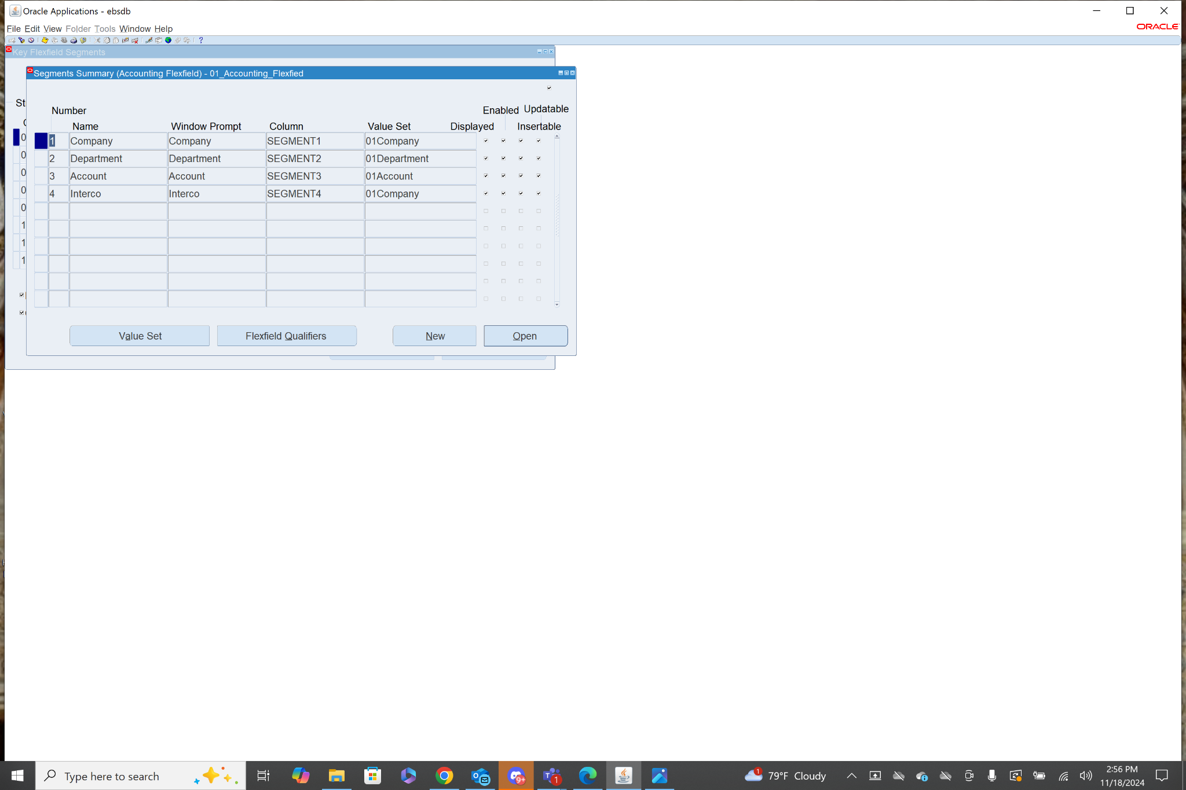

10. While under the General Ledger Responsibility you click View from the list of tools at the top of the page, then choose requests from the drop down menu.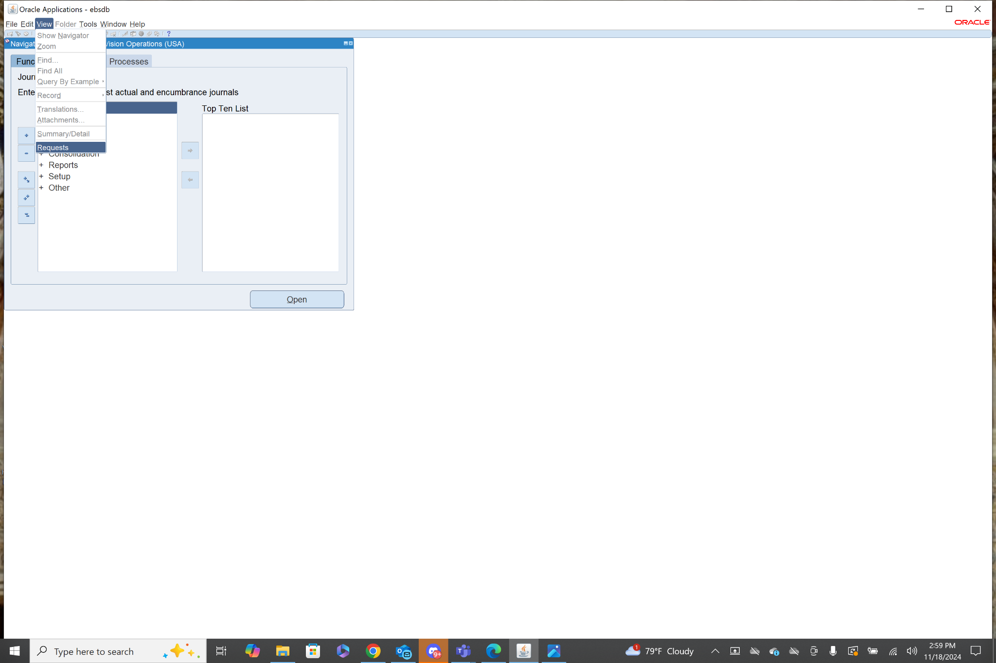

From here you click submit a new request.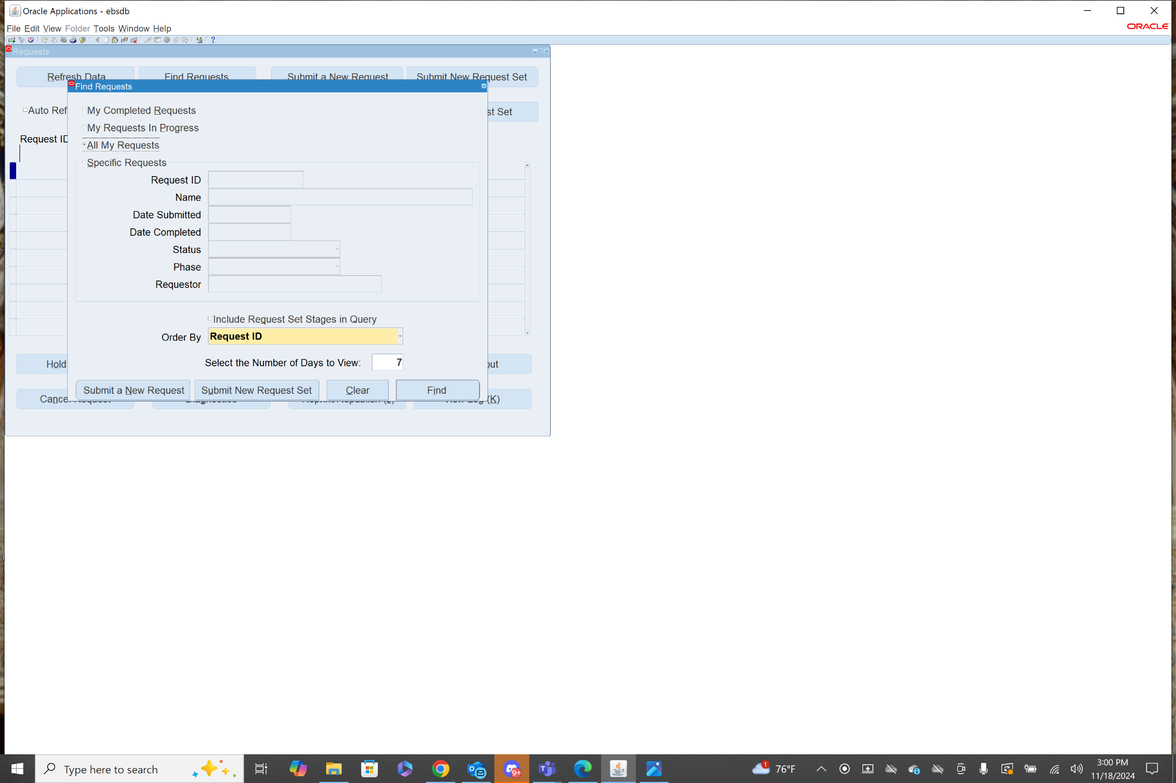

When in the submit request menu, you can choose a request from the list in the name field.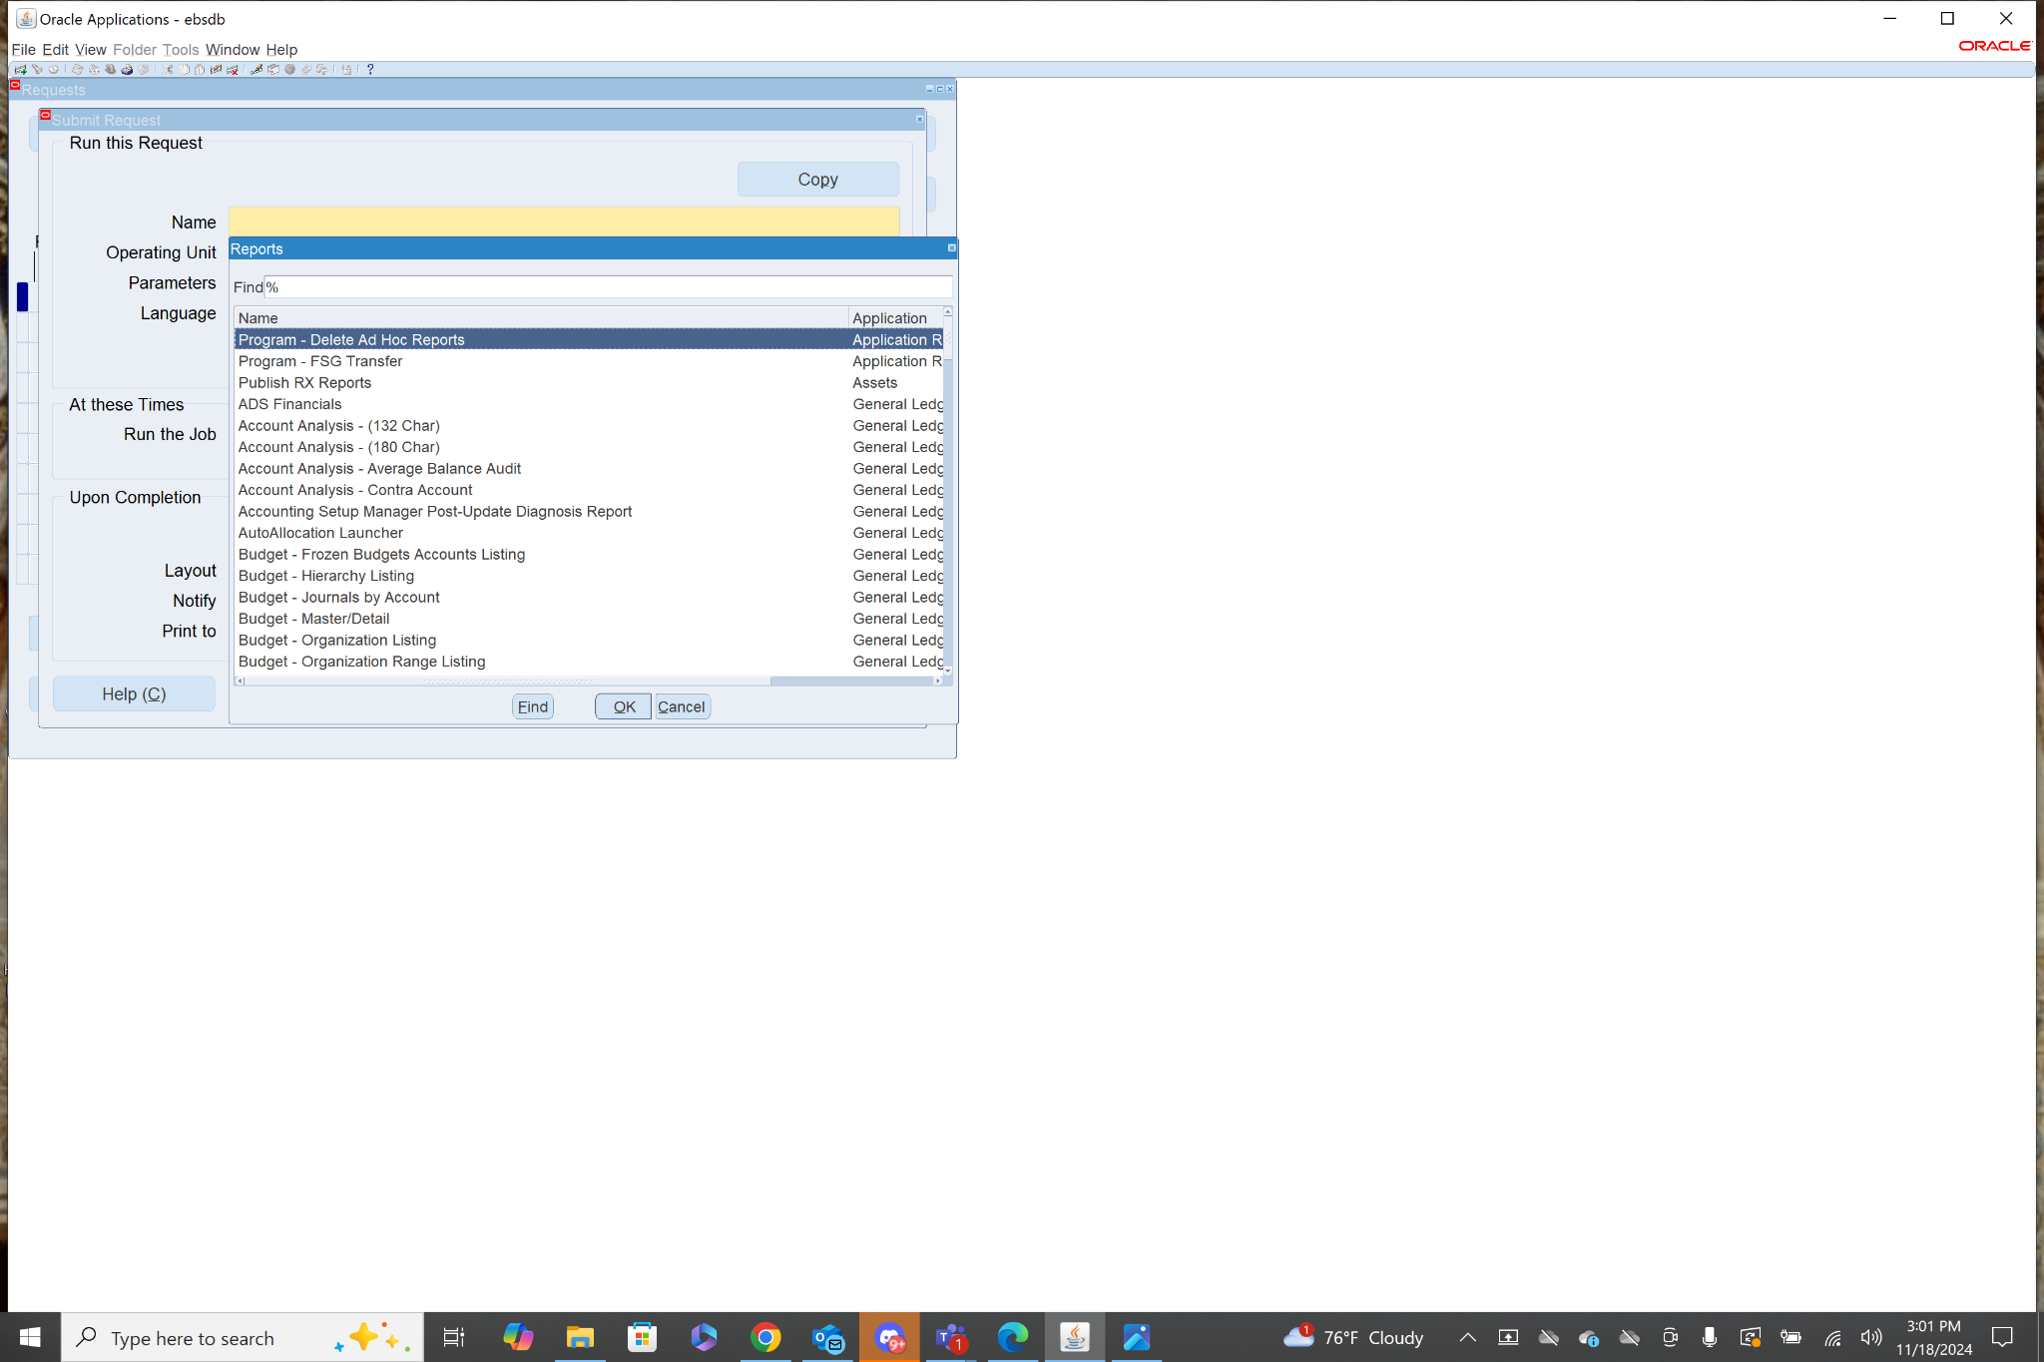

After you select the request you would like to run. Click Submit.

11. Every ledger set includes the 4C components.

Chart of Accounts: all ledgers in a ledger set must share the same chart of accounts structure.

Calendar: all ledgers in a ledger set must share the same accounting calendar.

Currency: all ledgers in a ledger set must use the same primary currency.

Subledger Accounting Method: all ledgers in a ledger set must share the same SLA method to ensure consistency.

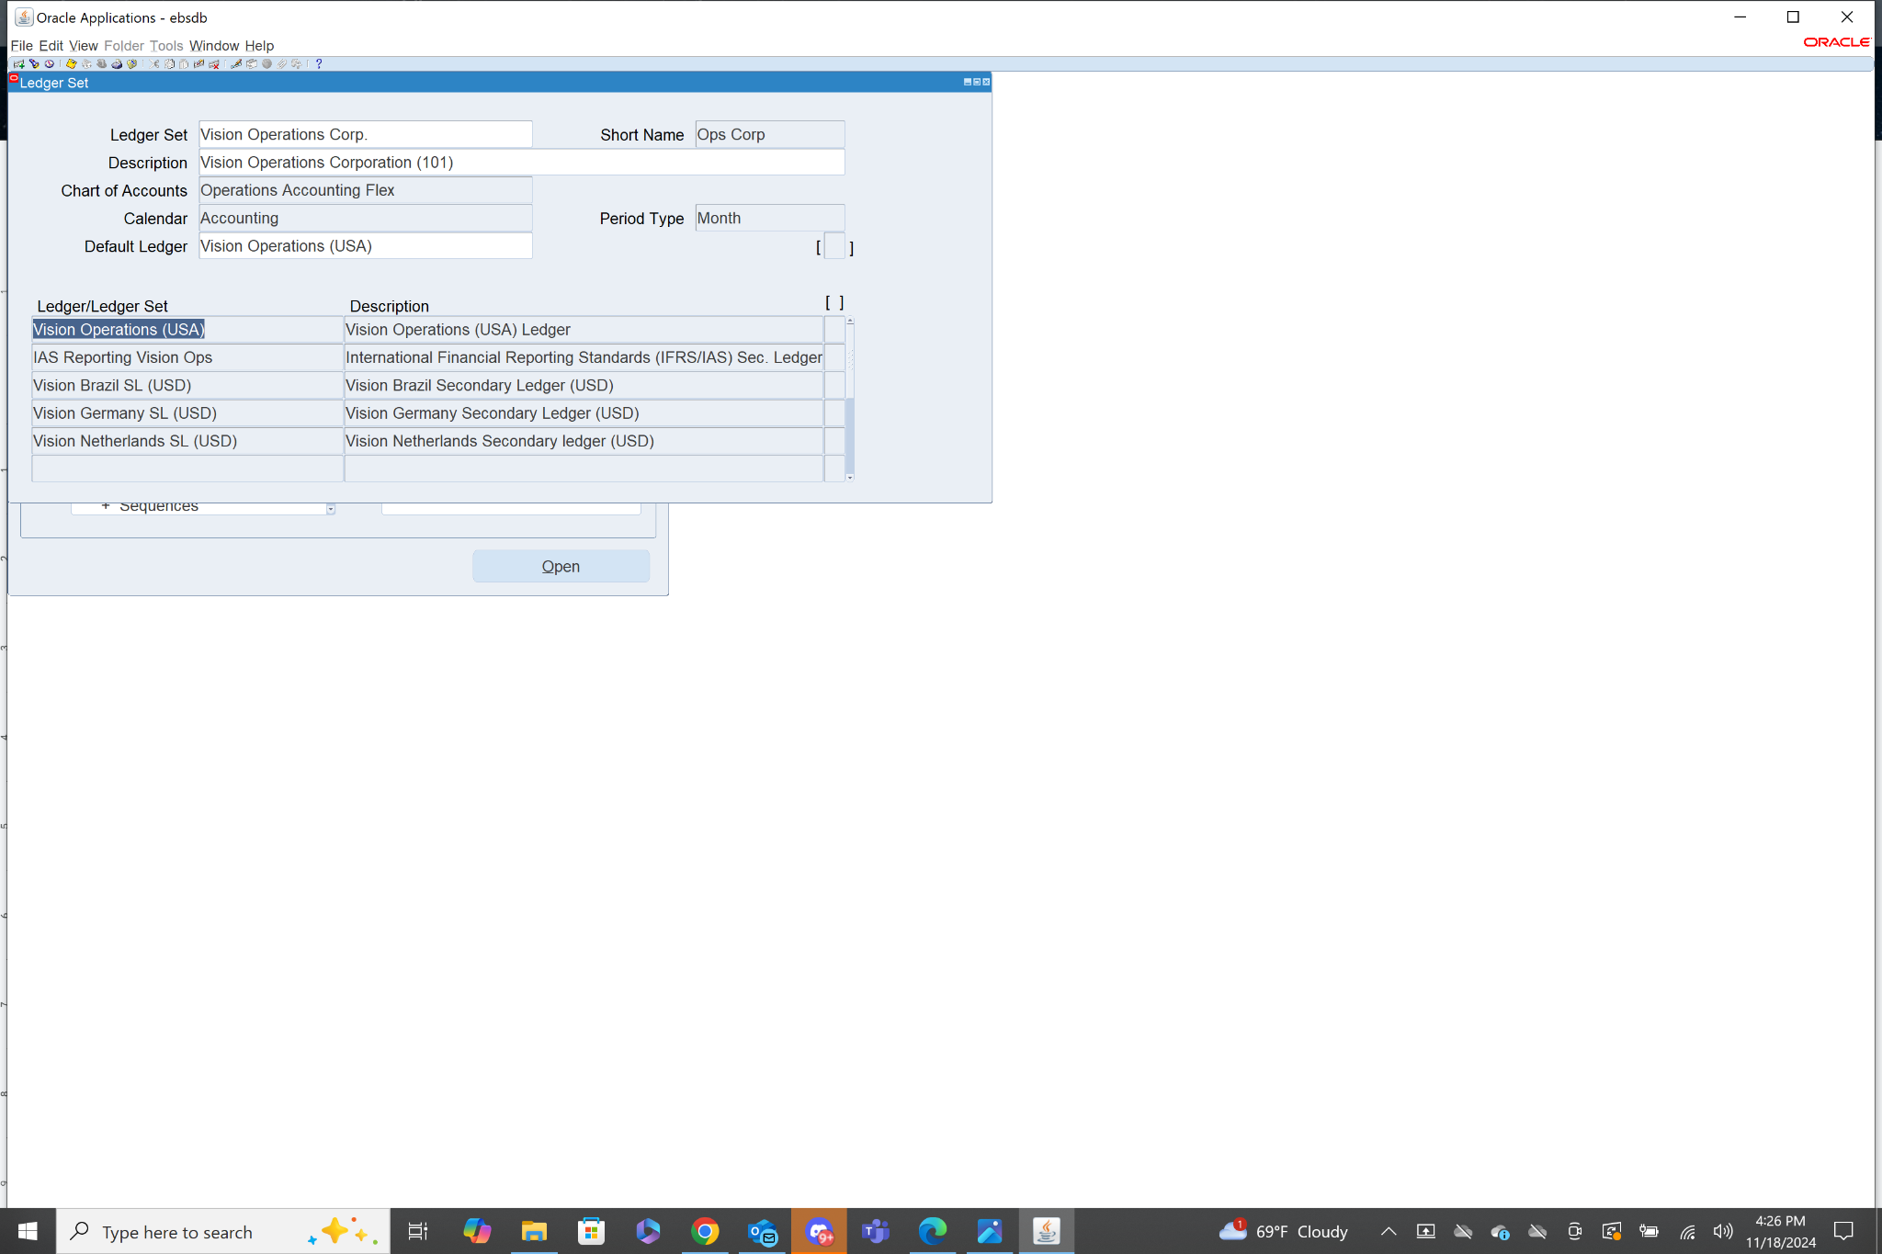

12. There are 5 types of accounts in Oracle GL including: Asset, Liability, Revenue, Expense, and Owners Equity. These refer to credits and debits that happen on a balancing sheet.

